Objectives:

* Writing and reading files
* Try and catch statement
* Intro to GUI Interfaces

**There are 4 print screens, each worth 25%**

**Project #1** (Based on Chapter 6 Files and Exceptions)



**#1 print screen the output with code below here**

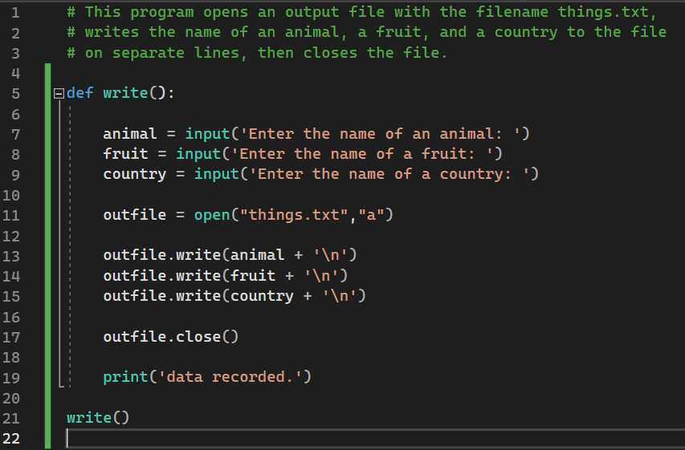

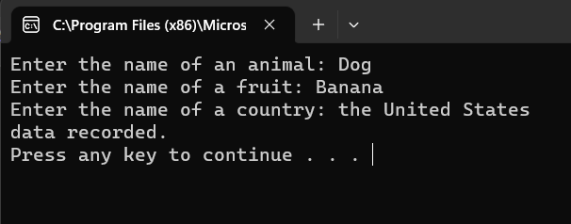



**#2 print screen the output with code below here**

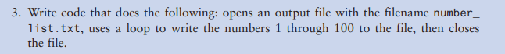

**#3 print screen the output with code below here**

**Project #2 (**Create a **GUI** application for the following below)

Be sure to create a GUI application using Tkinter

Use the following numbers inside a text file

100-1000

Example

100

200

300

**#4 print screen the output with code below here**

**Submit this document to Module 6 homework**